

**LIBRARY MANAGEMENT SYSTEM**

**A MINI PROJECT REPORT**

|  |  |
| --- | --- |
| **SUBMITTED** | **BY** |
|  |  |
| **THIRUMALAI J** | **231501174** |
| **KIRAN RAJAN S** | **231501507** |
| **SANTHOSH RAGHAVENDRA T J** | **231501508** |

**CS23333 OBJECT ORIENTED PROGRAMING USING JAVA**

**Department of Artificial Intelligence and Machine Learning**

**Rajalakshmi Engineering College, Thandalam.**

**2024-2025**

**BONAFIDE CERTIFICATE**

Certified that this project report “**LIBRARY MANAGEMENT SYSTEM**” is the bonafide work of **“THIRUMALAI J (231501174),KIRAN RAJAN S (231501507),SANTHOSH RAGHAVENDRA T J (231501508)”.**

who carried out the project work under my supervision.

**Submitted for the Practical Examination held on _______________________**

**SIGNATURE**

|  |  |  |  |
| --- | --- | --- | --- |
|  |  |  |  |
|  |  |  |  |
|  |  |  |  |
| **INTERNAL** | **EXTERNAL** |  |  |
|  |  |  |  |

**ABSTRACT**

This report describes the project development of Library Management System that was developed to manage the daily book transaction and manage the member, books record more efficiency. It can improve management of the book property in the library.

This library management system is mainly use by librarian and library admin. Normal Librarian is able to manage the member maintenance module, book maintenance module and also the most important module in a library which is book transaction module. Besides that, library management system also allows user to manage the publisher as well as lost book module. On the other hand, other type of user which is admin level staff is able to handle the staff module and view the report module.

The Online Library Management has been designed to computerize and automate the operations performed over the information about the members, book issues and returns and all other operations. This computerization of library helps in many instances of its maintenances. It reduces the workload of management as most of the manual work done is reduced.

Compare to the existing library system, this system has some strength and weaknesses compare to others such as lack of OTP , due message reminder to the user and smart card technology. In the future, we can enhance the system with OTP, due message sender , smart card technology to make it more perfect.

## TABLE OF CONTENTS

**Chapter TITLE Page**

**No. No.**

**ABSTRACT** **v**

**LIST OF FIGURES** **viii**

**LIST OF ABBREVIATIONS** **ix**

1. **INTRODUCTION 10** 
   1. Overview of project 10
2. **LITERATURE REVIEW 11**
3. **AIM AND SCOPE OF PRESENT INVESTIGATION 13** 
   1. Aim of the project 13
   2. Background of the project 13
   3. Development environment 14
   4. Operation environment 15

* 1. System Testing 15
     1. Unit Testing 15
     2. Integration Testing 16

1. **EXPERIMENTAL OR MATERIAL METHODS 17** 
   1. Module description 17
   2. Problem statement 19

* 1. Data flow diagram 20
     1. Level 1 dfd 20

1. **RESULTS AND PERFORMANCE ANALYSIS 22** 
   1. Output 22

* 1. Database 26

1. **PROGRAM CODE** **29** 
   1. Conclusion 29
   2. Future enhancement 29

**REFERANCE 30**

# LIST OF FIGURES

|  |  |  |
| --- | --- | --- |
| **FIGURE NO:** | **FIGURE NAME** | **PAGE NO** |
|  |  |  |
| 4.1 | Admin module | 17 |
| 4.2 | Member Registration | 19 |
| 4.3 | Book | 20 |
| 4.4 | Return | 20 |
| 5.1 | Login page | 21 |
| 5.2 | Main page | 21 |
| 5.3 | Book details | 22 |
| 5.4 | Add books | 22 |

# LIST OF ABBREVIATIONS

OTP -One Time Password

IDE - Integrated Development Environment

GUI - Graphical User Interface

**CHAPTER 1**

**INTRODUCTION**

## 1.1 OVERVIEW OF PROJECT

The project titled Library Management System is Library Management.

Software for monitoring and controlling the transaction in a library. The project “**Library Management System”** is developed in java. Which mainly focuses on basic operation in a library like adding new student, new books, and updating new information, searching books and students and facility to borrow and return books.

“Library Management System” is a windows application written for 32-bit or 64-bit windows operating system, designed to help users maintain and organize library .Our software is easy to use for both beginners and advanced users.it feature a familiar and well thought out and attractive user interface, combined with strong searching helps to get a good idea of which are the books borrowed by the members, makes user possible to generate reports next feature sequence. if a fall accident event takes place, the user’s hard copy.

**CHAPTER 2**

**LITERATURE SURVEY**

The researcher has made extensive literature survey on the topic under present study. There are number of papers on different aspects of open source software, such as, evaluation, case study, implementation, comparison etc. However, the purpose of present research article is to focus on the notion of survey of open source library management systems and find development activity only. In order to bring rigor into argumentation, the present study is exclusively concentrated on open source LMS related research articles and the articles listing, describing and critically analyzing open source library management systems. Following are some of the studies, which are delineated as follows: Bretthauer, D. (2001) gives overview of open source software and describes open source solution for libraries at that time. Again, in 2002, Bretthauer, D. (2002) presents actual status and updates on open source software for libraries. Catherine, E. (2002) provides an overview of present state of ILS development. Breeding, M. (2002) provides the information about Koha, Learning Access ILS, and Avanti Micro LCS Integrated Library system. Boss, R. W. (2005), in his article provides criteria and on the basis this criteria he has evaluated 12 open source library management systems, such as, Avanti Micro LCS, Emilda, Evergreen, Firefly, GNUteca, Koha, Learning Access ILS, Openbiblio, PhpMyLibrary, PMB, PYTHEAS and WEBLIS. Breeding, M. (2007), in his article, provides up-to-date information about Koha Evergreen and learning access ILS, integrated library system. The author gives comprehensive information about latest developments in software since 2002. DeVoe, K. (2007) provides a brief overview of nine open source integrated library. The author also put focus on the apparent advantages of open source software over commercial software, as well as its potential disadvantages. Breeding Marshall (2008) provides thorough information on Koha, Evergreen and OPALS, New Gen Lib. He also provides information on trends in open source ILS adoption. Boss, R. W. (2008) identified 12 integrated library management systems with some current development activity underway as early 2008. Balnaves E. (2008) has evaluated seven open source library management systems, such as, Emilda, Evergreen, Gnuteca, Koba, Open Biblio, Php My Library, PMB on five dimensions like functional dimension, architecture dimension, community dimension, code dimension, and schema dimension. Breeding, M. (2009) focuses on questions regarding to what extent open source ILS products can be considered viable alternatives. He looks open source ILS viability from four perspectives: market acceptance, support options, product development and functionality, and risk factors Müller, T. (2011) has identified 20 open source integrated library systems in his article and analyzed these systems using three-step process, such as, licensing, community and functionality. IAEME 40 Sunil M. V. and Harinarayana, N. S. (2011) has presented the requirement of Indian college libraries in integrated library system and evaluated nine open source library management softwares, such as, ABCD, Emilda, Evergreen, Koha, New Gen Lib, OPALS, Open bibilo, PMB and

PhpMyLibrary against the listed criteria from college library perspective. Kamble V.T., Hans Raj and Sangeeta (2012) describe briefly about the feature of some of the open source library management softwares like Greenstone Digital Library, D Space, Koha, E-Prints, New Gen lib. PhpMyLibrary, Open Biblio, Avanti. Salve, A., Lihitkar, S. R., and Lihitkar, R. (2012) provide the information on the general and specific features of content management system and digital library software and 13 integrated library management software, such as, Koha, New Gen Lib, Evergreen, Openbiblio, OPALS, Avanti Micro LCS, ABCD, Emilda, WEBLIS, Php My Library, GNU Library Management System, BiblioteQ, Java cataloguing system.

**CHAPTER 3**

**AIM AND SCOPE OF THE PRESENT INVESTIGATION**

## 3.1 AIM OF THE PROJECT

The project aims and objectives that will be achieved after completion of the system were carried out in this sub chapter. The succession of the system also will be evaluated through this sub chapter.

The project objectives are:

* To eliminate the paper-work in library

-

* To record every transaction in computerized system so that problem such as record file missing won’t happen again

Library Management System is an application refer to other library system and it is suitable to use by small and medium size library. It is use by librarian and library admin to manage the library using a computerized system. The system was developed and designed to help librarian record every book transaction so that the problem such as file missing or record missing will not happened again.

## 3.2 BACKGROUND OF THE PROJECT

Book and member maintenance module also included in Library Management System. Users can register or edit the member or book in the system. With this computerized maintenance, library will not lost the book record or member record which always happen when no computerized system bring used.

In addition, report module is also included in Library Management System.

If user’s position is Admin, the user is able to view different kind of report. First type of report are rental and return report, user can check the rental, return transaction which happen on particular day. Besides that, user can check the Top10 books which borrow by the member in a day, month or year based on category. Moreover, activity log report also provided by system so that admin can check what process has been carried out such as register new book, edit member information as well as login, logout information.When user lost the book, user can use Lost Book Module to register the lost book and receive the fine which is double price of that book.All these modules are able to help librarian to manage the library more convenience and efficiency compare to those library without computerized system.

## 3.4 Development Environment Software

* Operating system: Windows 10

Window 10 is selected as my developing operating system because it is more stable then Window 7. The advantage of Window 10 over Window 7 is able to run a lot applications and hardware that is not compatible with Window 7. We choose Window 10 to avoid this kind compatibility problem.

* Database: Xampp(MySql)

So I decide to use Microsoft SQL Server as the database software for my system. In addition, SQL Server enables us to copy or move the database to another computer easily. This is very useful when we developing the Library Management System.

* Development tools and programming language: NetBeans IDE and java

We would like to use as NetBeans our developing software. NetBeans is powerful and flexible developing software, it allows us to build a good design application. We can see the user-friendliness of our application .

## Hardware

• Processor: Intel core i5 8 th Gen Processor provide better processing capabilities and better cooling technology to our CPU. With an Intel processor, we can run our laptop for long time without need to switch off. Besides that, intel processor can help us to boost up the CPU processing power. By using this, we can keep developing the Library Management System without need to worry that the laptop cannot support.

➢ Ram: 8 Gb

In order to support NetBeans and SQL Server, we use 8Gb Ram to avoid any problem occurred during development phase. Besides that, SQL Server can process faster when running SQL statement with 8Gb ram. It can save a lot of time if total up the process time.

## 3.4 Operation Environment

The table shown below is the minimum requirement :

|  |  |
| --- | --- |
| Processor | Intel Pentium 233Ghz or better performance |
| Operating System | Microsoft Window XP, Vista or Window 7 |
| Memory | 2GB RAM |
| Screen  Resolution | Minitor with screen resolution minimum 1024 x 768 |
| Hard disk Space | Minimum 5GB to include database usage for future |
| Database | Microsoft SQL Server 2008 |

Figure 3.1 Table for operation environment

## 3.5 System Testing

The aim of the system testing process was to determine all defects in our project .The program was subjected to a set of test inputs and various observations were made and based on these observations it will be decided whether the program behaves as expected or not. Our Project went through two levels of testing

1.Unit testing

2.integration testing

### 3.5.1 Unit Testing

Unit testing is undertaken when a module has been created and succesfully reviewed .In order to test a single module we need to provide a complete environment ie besides the module we would require

* The procedures belonging to other modules that the module under test calls
* Non local data structures that module accesses
* A procedure to call the functions of the module under test with appropriate parameters
* Testing admin login form-This form is used for log in of administrator of the system.In this we enter the username and password if both are correct administration page will open other wise if any of data is wrong it will get redirected back to the login page and again ask for username and password
* Student account addition- In this section the admin can verify student details from student academinc info and then only add student details to main library database it contains add and delete buttons if user click add button data will be added to student database and if he clicks delete button the student data will be deleted.

Book Addition- Admin can enter details of book and can add the details to the main book table also he can view the books requests .

2. Test for Student login module

* Test for Student login Form-This form is used for log in of Student .In this we enter thelibraryid, username and password if all these are correct student login page will open other wise if any of data is wrong it will get redirected back to the login page and again ask for libraryid, username and password.
* Test for account creation- This form is used for new account creation when student does not fill the form completely it asks again to fill the whole form when he fill the form fully it gets redirected to page which show waiting for conformation message as his data will be only added by administrator after verification. 3. Test for teacher login module

Test for teacher login form- This form is used for log in of teacher .In this we enter the username and password if all these are correct teacher login page will open other wise if any of data is wrong it will get redirected back to the login page and again ask for username and password.

### 3.5.2 Integration Testing

In this type of testing we test various integration of the project module by providing the input .The primary objective is to test the module interfaces in order to ensure that no errors are occurring when one module invokes the other module

**CHAPTER 4**  **EXPERIMENTAL OR MATERIAL METHOD**

## 4.1 MODULE DESCRIPTION

### • Authorization and Authentication Module



Password Recovery



ID / Password

Checking



Authorization and Authentication

This module is used by user which means librarian in the library. They need to login to the system using their id and password. In order to distinguish the user’s level, user can access to different module when successfully login. For example, only admin level users are able to access the report

### • Member Maintenance Module



Search

Member



Edit

member



Add new

member



Member Maintenance

This module can be accessed by either librarian or library admin to maintain member’s profile or record such as search, add, edit.

### • Book Maintenance Module



Search

book



Edit book

information



Add new

book



Book Maintenan

ce

Book Module can access by any user from all levels. This module can used to maintain the book inventory record such as search, add and edit.

### • Member/Staff Maintenance Module



View

Staff/Member



Change

Password



Edit

Staff/Member



Member/Staff

Maintenance

This module allows user and also admin to view their profile. Not only that, they allow to edit their profile and also change their password.

### • Search Module

Search module allow user or guess who visit website to search the book. Not only that the user allow viewing the detail of the book and also seeing the comment of the book. There are a few of type allow users to search.

They can search via ISBN, book title, author, publisher, and category.

### • Admin Module

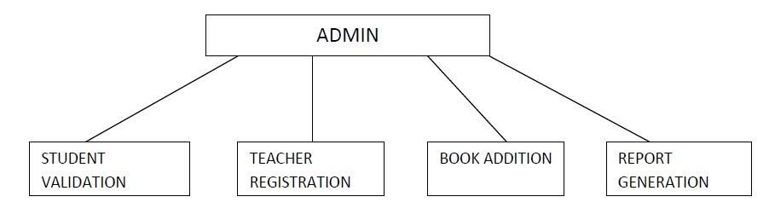

Figure 4.1 for Admin Module

## 4.2 Problem Statement

The problem occurred before having computerized system includes:

### • File lost

When no computerizes system is implemented, the file always lost because of human and environment. Sometimes librarian didn’t keep the record to its original place because of a lot member queue up to borrow books. After that the file was missing due to messy environment.

### • File damaged

In the other possibility, the file/record will be damaged due to accident. For example the librarian accidentally hit a glass of drink and pours onto the paper file. The record will be damaged. Besides this, natural disaster such as flood also will cause damage to the file record.

### • Difficult to search record

Without computerized system, when member wants to borrow a book, librarian hard to search for the member’s record. It will cause timeconsuming when a lot member are waiting to borrow the books.

### • Space-consuming

After long operation time of the library, the records are getting more and more. Finally, the physical record was space-consuming and no place to keep the file.

### • Difficult to view reports

Report need to generate manually without computerizes system. Admin need to get the book transaction record and find the information based on the time period. It is time consuming to generate one report.

### • Cost consuming

Paper is needed to add every new record. After a long period of time, the cost to buy a paper can be high. On the other hand, library needs to employ more staff to solve the long queue problem. If the library only has one staff, it is not enough time to process the book transaction

**4.3 Data Flow Diagram**

**4.3.1Level 1DFD (Lower – Level Diagram)**

1. Member Registration

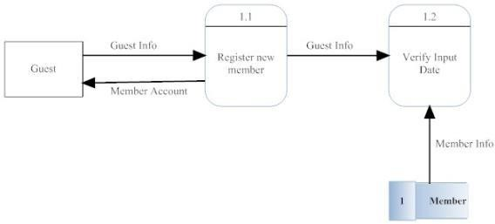

Figure 4.2 for Member Registration

1. Book Rental

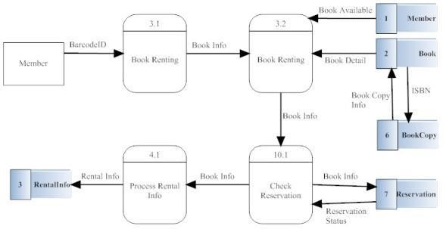

Figure 4.3 for Book Rental

1. Return book

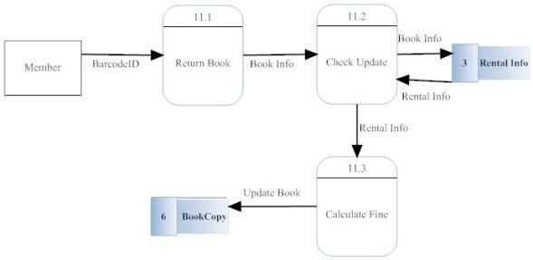

Figure 4.4 for Return book

**CHAPTER 5 RESULTS AND PERFORMANCE ANALYSIS**

## 5.1 OUTPUT

### 1.Login page

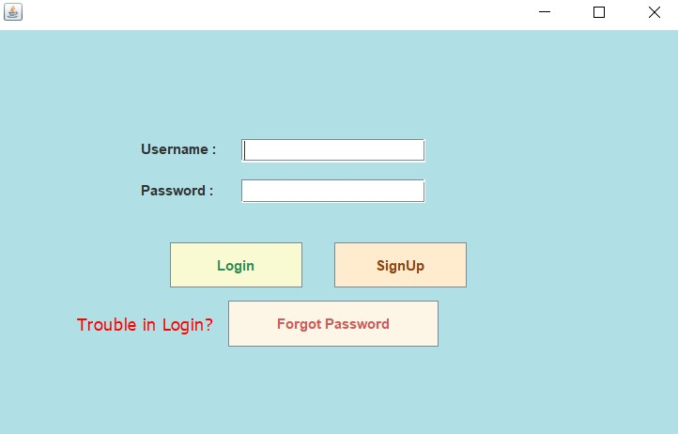

#### Fig:5.1 login page

This is the login page for librarian and admin. The form is designed without colorful interface because it is used by librarian and admin which can be considered as backend. The login interface is simply design with ID and password textbox.

### 2.Main page

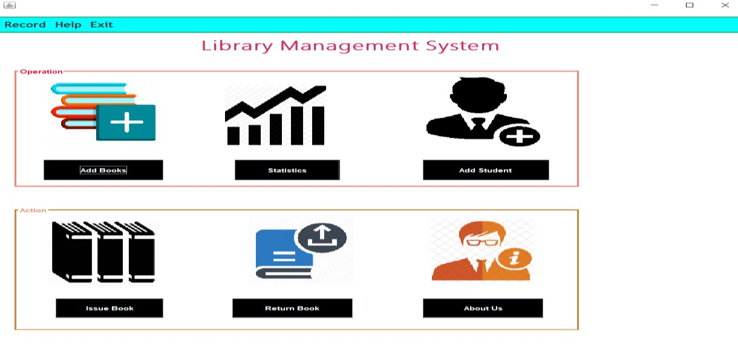

#### Fig:5.2 Main page

Figure 2.1 is the main page for library system. In is the form where statistics, about us, Return books, issue books , add books module was carried out. The top left part show the record ,help,exit.

### 3.Book Details

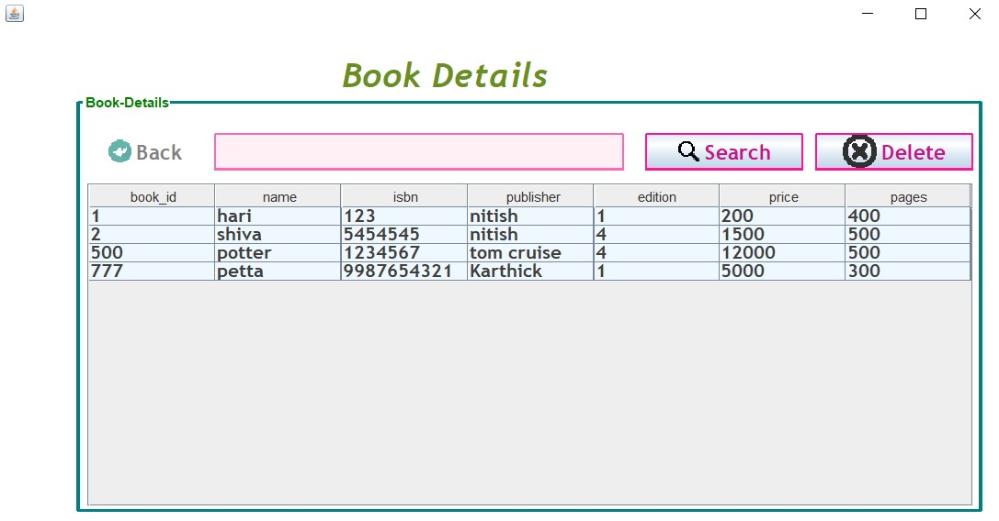

#### Fig:5.3 Book Details

This is the book Details form. It will show all books in library when the form is loaded. When user selects one of the books, its details will be shown. Search function is provided so that user can easily found the book if there are hundreds of book in the library.

### 4.Add Book

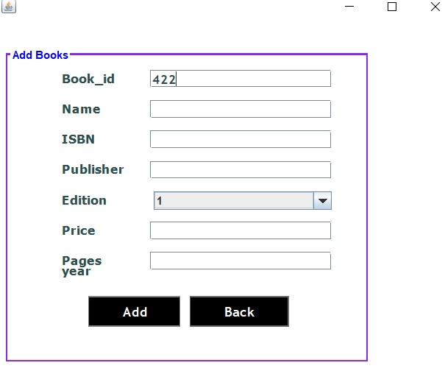

#### Fig:5.4 Add Book

Figure 5.4 which is Add Book . The form is provided with few textbox to insert the book information

### 6.Add student

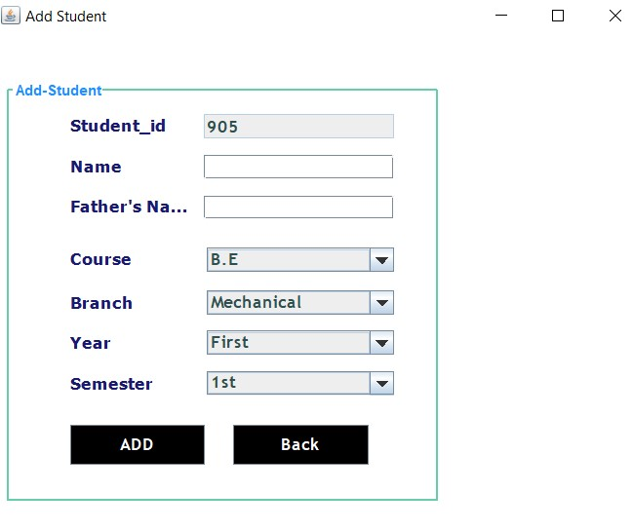

#### Fig:5.5 Add Student

Figure 5.5 shows the student registration form. The form only contains the few fields which user need to insert when register the member. A proper control has been used so that user can use the system easily. 7.Issue Book

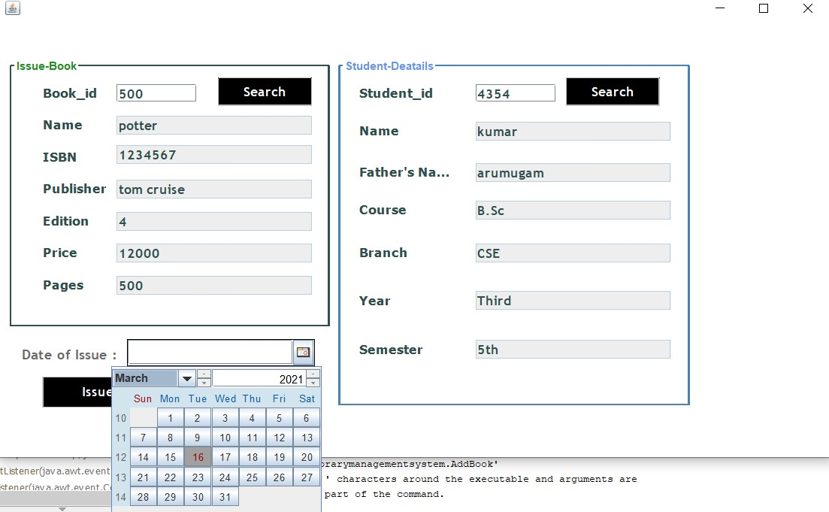

#### Fig:5.6 Issue Book

In the figure 5.6 the user/staff can issue the book.they can do this work easy by typing the book id and student id.It automatically get the datas from the database. And need to add the issue date and click the issue button.

##### 8. Return book

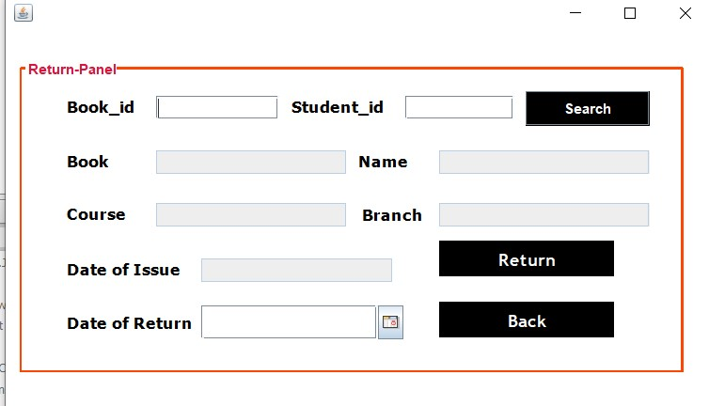

#### Fig:5.7 Return book

In this user/staff can apply for returning the book . It is the same process like the issue book. By typing book id and student id we can get the due. And return the book.

### 9.Student Details

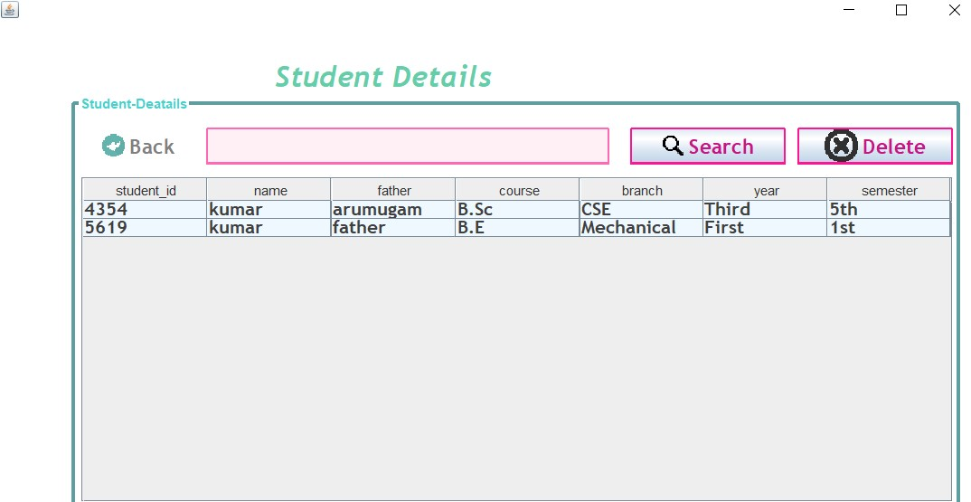

***Fig:5.7 Student Details*** in this staff/Admin can see the number of student registered in the library will be showed.

**5.2 Database**

**1. Database tables**

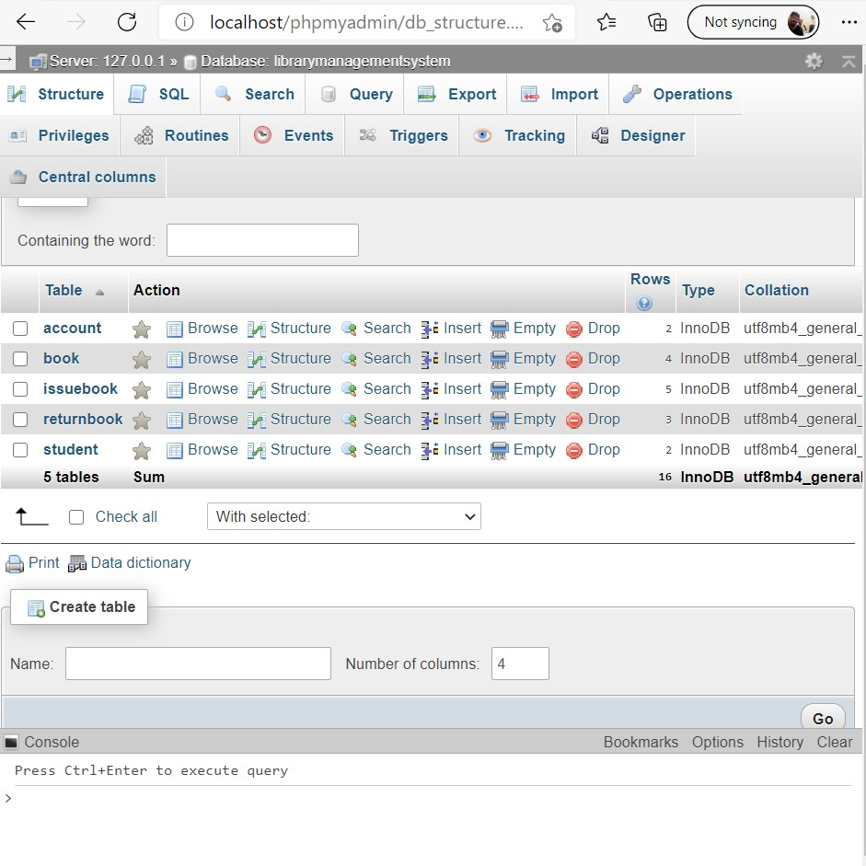

## *Fig:5.2.1 for database tables*

This is the database table .my data base name is librarymanagementsystem. in that there are 5 tables. account, book, issuebook, returnbook, student.

### 2. account tables

|  |  |  |  |
| --- | --- | --- | --- |
| **Column** | **Type** | **Null** | **Default** |
| Username | Varchar(20) | Yes | Null |
| Password | Varchar(25) | Yes | Null |
| Sec_q | Varchar(25) | Yes | Null |
| Sec_ans | Varchar(25) | Yes | Null |
| name | Varchar(40) | Yes | Null |

## *Table:5.2.2 for account tables*

This database show the amount of users have created the account.and the show the current users in the list . User name ,pasword ,sec q sec ans, name.

### 3. Books Tables

|  |  |  |  |
| --- | --- | --- | --- |
| **Column** | **Type** | **Null** | **Default** |
| Book_id | Varchar(10) | Yes | Null |
| Name | Varchar(40) | Yes | Null |
| Isbn | Varchar(20) | Yes | Null |
| Publisher | Varchar(30) | Yes | Null |
| Edition | Varchar(10) | Yes | Null |
| Price | Varchar(10) | Yes | Null |
| page | Varchar(10) | Yes | Null |

## *Table :5.2.3 for Book tables*

This table show the how many book are currently in the library. With book id , name, isbn , publisher , edition, price ,pages.

## 4.Issue book

|  |  |  |  |
| --- | --- | --- | --- |
| **Column** | **Type** | **Null** | **Default** |
| Book_id | Varchar(10) | Yes | Null |
| Student_id | Varchar(10) | Yes | Null |
| Bname | Varchar(40) | Yes | Null |
| Sname | Varchar(40) | Yes | Null |
| Course | Varchar(20) | Yes | Null |
| Branch | Varchar(10) | Yes | Null |
| Date of  issue | date | Yes | Null |

### *Table:5.2.4 for Issue Book*

This tables show the number of book issued to the users/students.

In this book id , student id , bname, sname, course , brance, dataof issue.

#### 5. Return Book

|  |  |  |  |  |
| --- | --- | --- | --- | --- |
| **Column** | | **Type** | **Null** | **Default** |
| Book_id | | Varchar(10) | Yes | Null |
| Student_id | | Varchar(10) | Yes | Null |
| Bname |  | Varchar(40) | Yes | Null |
| Sname |  | Varchar(40) | Yes | Null |
| Course |  | Varchar(20) | Yes | Null |
| Branch |  | Varchar(10) | Yes | Null |
| Date issue | of | Varchar(30) | Yes | Null |
| Date return | of | Varchar(30) | Yes | Null |

### *Table :5.2.5 for Return Book*

This tables show the number of book Return from the users/students.

In this book id , student id , bname, sname, course , brance, dataof issue , date of return

## 6.Student

|  |  |  |  |
| --- | --- | --- | --- |
| **Column** | **Type** | **Null** | **Default** |
| Student_id | Varchar(10) | Yes | Null |
| Name | Varchar(25) | Yes | Null |
| Father | Varchar(25) | Yes | Null |
| Course | Varchar(10) | Yes | Null |
| Branch | Varchar(10) | Yes | Null |
| Year | Varchar(10) | Yes | Null |
| Semester | Varchar(10) | Yes | Null |

### *Fig:5.2.6 for Student*

This tables show the number of Student in the database.In this student id , name, father, course , brance, year , semester.

**PROGRAM CODE**

import javax.swing.*;

import javax.swing.table.DefaultTableModel;

import java.awt.*;

import java.awt.event.ActionEvent;

import java.awt.event.ActionListener;

import java.util.ArrayList;

public class LibraryManagementSystem2 {

  private JFrame frame;

  private JTable table;

  private DefaultTableModel tableModel;

  private JTextField searchField;

  private ArrayList<Book> books;

  public LibraryManagementSystem2() {

    books = new ArrayList<>();

    frame = new JFrame("Library Management System");

    frame.setDefaultCloseOperation(JFrame.EXIT_ON_CLOSE);

    frame.setSize(900, 500);

    frame.setLayout(new BorderLayout());

    tableModel = new DefaultTableModel(new Object[] { "Title", "Author", "Description" }, 0);

    table = new JTable(tableModel);

    JScrollPane scrollPane = new JScrollPane(table);

    JPanel controlPanel = new JPanel(new FlowLayout());

    JButton addButton = new JButton("Add Book");

    JButton deleteButton = new JButton("Delete Book");

    JButton editButton = new JButton("Edit Book");

    controlPanel.add(addButton);

    controlPanel.add(deleteButton);

    controlPanel.add(editButton);

    JPanel searchPanel = new JPanel(new FlowLayout());

    searchField = new JTextField(20);

    JButton searchButton = new JButton("Search");

    JButton viewAllButton = new JButton("View All");

    searchPanel.add(new JLabel("Search by Title/Author:"));

    searchPanel.add(searchField);

    searchPanel.add(searchButton);

    searchPanel.add(viewAllButton);

    addButton.addActionListener(e -> addBook());

    deleteButton.addActionListener(e -> deleteBook());

    editButton.addActionListener(e -> editBook());

    searchButton.addActionListener(e -> searchBooks());

    viewAllButton.addActionListener(e -> viewAllBooks());

    frame.add(scrollPane, BorderLayout.CENTER);

    frame.add(controlPanel, BorderLayout.NORTH);

    frame.add(searchPanel, BorderLayout.SOUTH);

    frame.setVisible(true);

  }

  private void addBook() {

    JTextField titleField = new JTextField(10);

    JTextField authorField = new JTextField(10);

    JTextArea descriptionArea = new JTextArea(3, 10);

    JPanel panel = new JPanel();

    panel.setLayout(new BoxLayout(panel, BoxLayout.Y_AXIS));

    panel.add(new JLabel("Title:"));

    panel.add(titleField);

    panel.add(new JLabel("Author:"));

    panel.add(authorField);

    panel.add(new JLabel("Description:"));

    panel.add(new JScrollPane(descriptionArea));

    int result = JOptionPane.showConfirmDialog(frame, panel, "Add New Book", JOptionPane.OK_CANCEL_OPTION,

        JOptionPane.PLAIN_MESSAGE);

    if (result == JOptionPane.OK_OPTION) {

      String title = titleField.getText().trim();

      String author = authorField.getText().trim();

      String description = descriptionArea.getText().trim();

      if (!title.isEmpty() && !author.isEmpty() && !description.isEmpty()) {

        Book book = new Book(title, author, description);

        books.add(book);

        tableModel.addRow(new Object[] { title, author, description });

      } else {

        JOptionPane.showMessageDialog(frame, "Please fill in all fields.", "Warning", JOptionPane.WARNING_MESSAGE);

      }

    }

  }

  private void deleteBook() {

    int selectedRow = table.getSelectedRow();

    if (selectedRow != -1) {

      books.remove(selectedRow);

      tableModel.removeRow(selectedRow);

    } else {

      JOptionPane.showMessageDialog(frame, "Please select a book to delete.");

    }

  }

  private void editBook() {

    int selectedRow = table.getSelectedRow();

    if (selectedRow != -1) {

      Book selectedBook = books.get(selectedRow);

      JTextField titleField = new JTextField(selectedBook.getTitle(), 10);

      JTextField authorField = new JTextField(selectedBook.getAuthor(), 10);

      JTextArea descriptionArea = new JTextArea(selectedBook.getDescription(), 3, 10);

      JPanel panel = new JPanel();

      panel.setLayout(new BoxLayout(panel, BoxLayout.Y_AXIS));

      panel.add(new JLabel("Title:"));

      panel.add(titleField);

      panel.add(new JLabel("Author:"));

      panel.add(authorField);

      panel.add(new JLabel("Description:"));

      panel.add(new JScrollPane(descriptionArea));

      int result = JOptionPane.showConfirmDialog(frame, panel, "Edit Book", JOptionPane.OK_CANCEL_OPTION,

          JOptionPane.PLAIN_MESSAGE);

      if (result == JOptionPane.OK_OPTION) {

        String newTitle = titleField.getText().trim();

        String newAuthor = authorField.getText().trim();

        String newDescription = descriptionArea.getText().trim();

        if (!newTitle.isEmpty() && !newAuthor.isEmpty() && !newDescription.isEmpty()) {

          selectedBook.setTitle(newTitle);

          selectedBook.setAuthor(newAuthor);

          selectedBook.setDescription(newDescription);

          tableModel.setValueAt(newTitle, selectedRow, 0);

          tableModel.setValueAt(newAuthor, selectedRow, 1);

          tableModel.setValueAt(newDescription, selectedRow, 2);

        } else {

          JOptionPane.showMessageDialog(frame, "Please fill in all fields.", "Warning", JOptionPane.WARNING_MESSAGE);

        }

      }

    } else {

      JOptionPane.showMessageDialog(frame, "Please select a book to edit.");

    }

  }

  private void searchBooks() {

    String searchText = searchField.getText().trim().toLowerCase();

    tableModel.setRowCount(0);

    for (Book book : books) {

      if (book.getTitle().toLowerCase().contains(searchText) || book.getAuthor().toLowerCase().contains(searchText)) {

        tableModel.addRow(new Object[] { book.getTitle(), book.getAuthor(), book.getDescription() });

      }

    }

  }

  private void viewAllBooks() {

    tableModel.setRowCount(0);

    for (Book book : books) {

      tableModel.addRow(new Object[] { book.getTitle(), book.getAuthor(), book.getDescription() });

    }

  }

  class Book {

    private String title;

    private String author;

    private String description;

    public Book(String title, String author, String description) {

      this.title = title;

      this.author = author;

      this.description = description;

    }

    public String getTitle() {

      return title;

    }

    public String getAuthor() {

      return author;

    }

    public String getDescription() {

      return description;

    }

    public void setTitle(String title) {

      this.title = title;

    }

    public void setAuthor(String author) {

      this.author = author;

    }

    public void setDescription(String description) {

      this.description = description;

    }

  }

  public static void main(String[] args) {

    SwingUtilities.invokeLater(LibraryManagementSystem2::new);

  }

}

**CHAPTER 6 CONCLUSION AND FUTURE ENHANCEMENT**

## 6.1 CONCLUSION

The Library Management System has been computed successfully and was also tested successfully by taking the test cases . it is user friendly , and has required options , which can be utilized by user to preform the desire operation .

The software is developed using java as the front end and MySql as the back end in windows environment. The goals that are achieved by the software are :

* Optimum utilization of resource.
* Efficient management of records.
* Simplification of the operation.
* Less processing time and getting required information.
* User friendly.
* Portable and flexible for further enhancement.

## 6.2 FUTURE ENHANCEMENTS

It is not possible to develop a system that makes all the requirements of the users. User requirement keep changing as the system is being used. Some of the future enhancements that can be done to this system are :

As the technology emerges, it is possible to upgrade the system and can be adaptable to desired environment.

Based on the future security issues , security can be improved using emerging technologies.

OTP generator , due date reminder can be added

**REFERANCE**

* Bretthauer, D. (2001) gives overview of open source software and describes open source solution for libraries at that time.
* 2002, Bretthauer, D. (2002) presents actual status and updates on open source software for libraries. Catherine, E. (2002) provides an overview of present state of ILS development. Breeding, M.
* (2002) provides the information about Koha, Learning Access ILS, and Avanti Micro LCS Integrated Library system.
* Boss, R. W. (2005), in his article provides criteria and on the basis this criteria he has evaluated 12 open source library management systems,
* Breeding, M. (2007), in his article, provides up-to-date information about Koha Evergreen and learning access ILS, integrated library system. The author gives comprehensive information about latest developments in software since 2002.
* DeVoe, K. (2007) provides a brief overview of nine open source integrated library.
* Breeding Marshall (2008) provides thorough information on Koha, Evergreen and OPALS, New Gen Lib. He also provides information on trends in open source ILS adoption. Boss, R. W. (2008) identified 12 integrated library management systems with some current development activity underway as early 2008. Balnaves E.
* Breeding, M. (2009) focuses on questions regarding to what extent open source ILS products can be considered viable alternatives. He looks open source ILS viability from four perspectives: market acceptance, support options, product development and functionality

30

* Risk factors Müller, T. (2011) has identified 20 open source integrated library systems in his article and analyzed these systems using three-step process, such as, licensing, community and functionality.
* IAEME 40 Sunil M. V. and Harinarayana, N. S. (2011) has presented the requirement of Indian college libraries in integrated library system and evaluated nine open source library management softwares,
* Salve, A., Lihitkar, S. R., and Lihitkar, R. (2012) provide the information on the general and specific features of content management system and digital library software and 13 integrated library management software.